**User Manual For Hosting GitHub Repository for Food Delivery Application**

Step 1. Creating a folder of Food Delivery Application

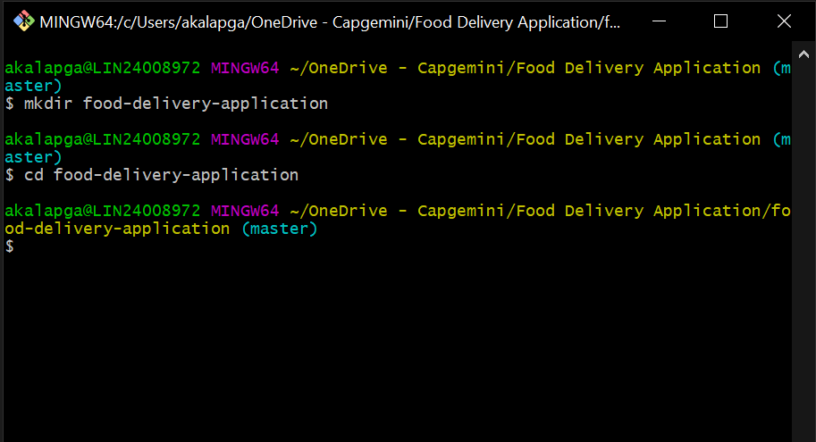

**Step 2. Initialising Git in that Folder**

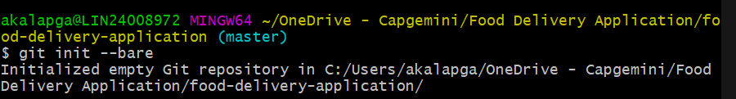

git init –bare

**Step 3. Open Git Bash on your Desktop or any Directory and initialise food delivery application**

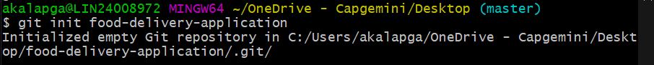

git init food-delivery-application

**Step 4. Go into that folder of food-delivery-application**



**Step 5. Add Remote Repository link, select the path of your one drive repository and paste it as shown below.**

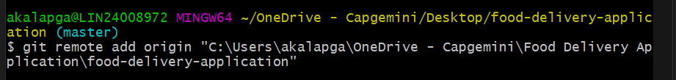

git remote add origin “path”

**Step 6. Check if remote repository is added correctly**

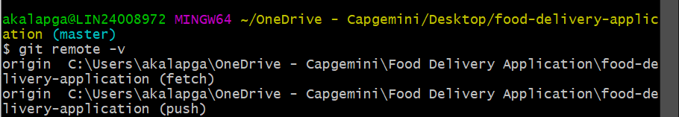

Git remote -v

**Step 7. Check Git Status**

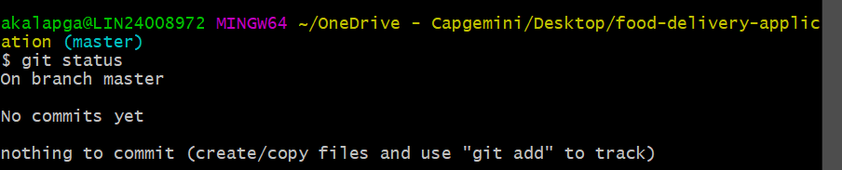

Step 8. Create a hello world text



Step 9. Git Commit Initialise Commit

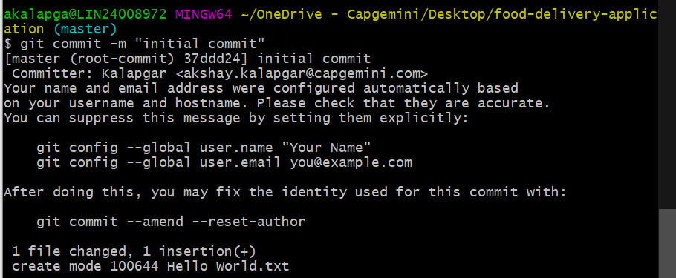

Step 10. Git push -u origin master to push the hello world text to git repository in one drive

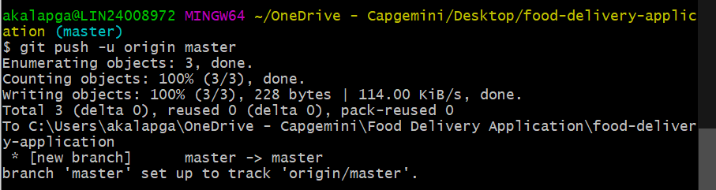

Step 11. Check Status and log

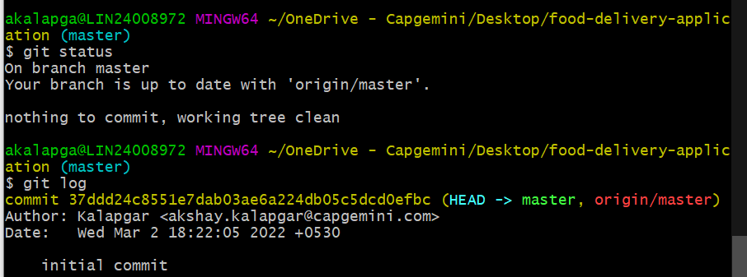

Now you can delete your local repo and clone from one drive and its done.

